Sacred Art
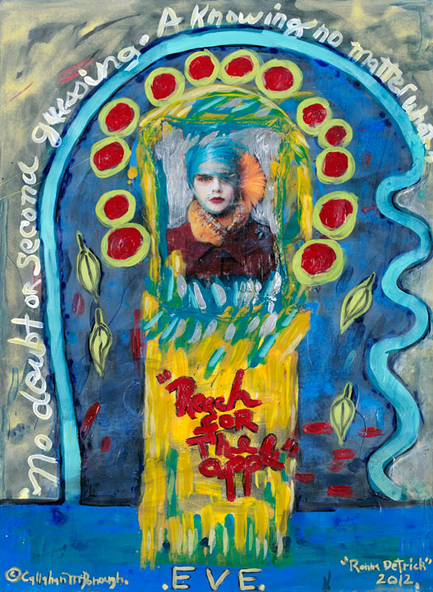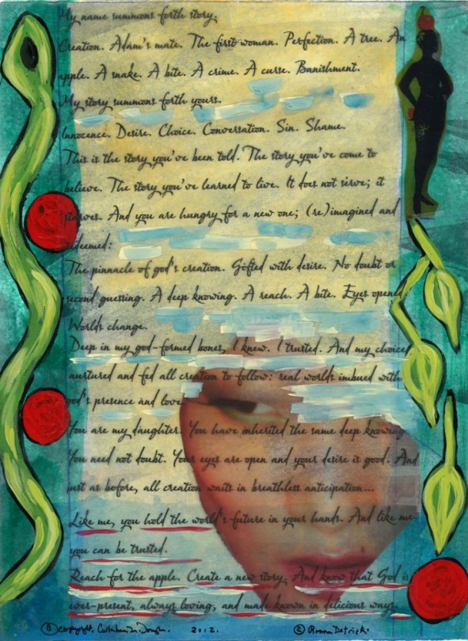Artist Callahan McDonough is helping me create and curate a collection of 30 unique (and gorgeous) paintings inspired by my writings that re-imagine and redeem the stories of women in Scripture.

Eve was where we had to begin.

T
towww

